ATM system

# Use case diagram

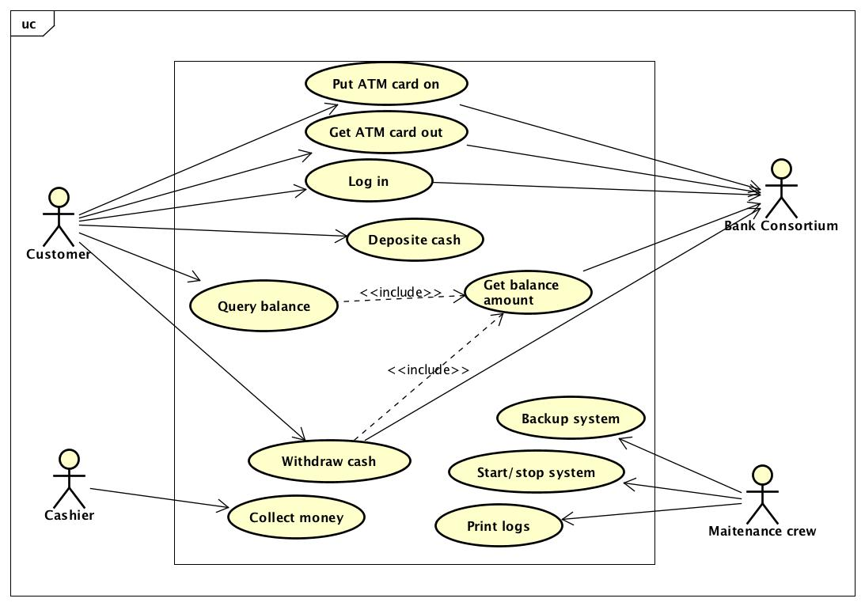

# Supplementary specification

## Functionality

The transaction amount should be in increments of VNĐ 10.000. The number of withdrawals per day is cannot exceed 4 times. The system will only accept ATM cards from participating banks.

## Performance / Efficiency

All 30 bank ATMs may be used simultaneously. The system should respond to requests in less than five seconds.

## Reliability

The system should be available for communication 97% of the time on a 24/7/365 basis.

## Usability

Screen should be easy to read and touch pads easy to use.

# Use case specification

## UC “Withdraw cash”

|  |  |  |  |
| --- | --- | --- | --- |
| UC Code | UC001 | Use case name | Withdraw cash |
| Actor | Customer, Bank Consortium | | |
| Precondition | Valid PAN and Successful Login | | |
| Main flow of event (success) | | # | Doer | Action | | --- | --- | --- | |  | Customer | chooses withdraw cash | |  | System | checks the status of the withdrawal chute | |  | System | displays withdrawal screen | |  | Customer | enters and submits the withdrawal amount | |  | System | checks if the withdrawal amount is in increments of VNĐ 10.000 | |  | System | checks if the number of withdrawals per day <= 4 times | |  | System | checks if the system has enough money to dispense | |  | System | checks if the customer balance is sufficient | |  | System | write the withdrawal amount and increase the count of withdrawals per day to unposted local file | |  | System | ejects ATM card | |  | System | dispense money | |  | System | send the withdrawal amount and the count of withdrawals per day to bank consortium | | | |
| Alternative flow of event | |  |  |  | | --- | --- | --- | | # | Doer | Action | | 3a. | System | notifies “Temporarily unable to process withdrawals” if the withdrawal chute is jammed | | 6a. | System | notifies “The amount should be in increments of VND 10.000” if the amount is not in increments of VND 10.000 | | 7a. | System | notifies “The number of withdrawals per day exceeds 4 times” if the number of withdrawals perday > 4 times | | 8a. | System | notifies “Machine cannot dispense that amount” if it doesnot have enough money | | 9a. | System | notifies error: “Insufficient Funds” if the balance is not sufficient | | | |
| Post condition | None | | |

## UC “Deposit cash”

|  |  |  |  |
| --- | --- | --- | --- |
| UC Code | UC002 | Use case name | Deposit cash |
| Actor | Customer | | |
| Precondition | Valid PAN and Successful Login | | |
| Main flow of event (success) | | # | Doer | Action | | --- | --- | --- | |  | Customer | chooses deposit cash | |  | System | checks if the status of the deposit envelope slot is good | |  | System | displays deposit screen | |  | Customer | enters and submits the deposit amount | |  | System | checks if the deposit amount is in increments of VNĐ 10.000 | |  | Customer | put envelope into deposit slot | |  | System | checks if the deposit amount matches to the deposit envelope | |  | System | writes the deposit amount and increase the count of deposit per day to unposted local file | |  | System | displays successfully deposit | | | |
| Alternative flow of event | |  |  |  | | --- | --- | --- | | # | Doer | Action | | 3a. | System | notifies “Temporarily unable to process deposit” if there is any problem with deposit envelope slot | | 6a. | System | notifies “The amount should be in increments of VND 10.000” if the amount is not in increments of VND 10.000 | | 8a. | System | notifies “The deposit amount doesnot match to the deposit envelope” if it doesnot match | | | |
| Post condition | None | | |